Gait evaluation using Skeleton Motion Detection from Videos using YOLO

Introduction
Gait is one of the most important functions of human beings and the most elementary form of moving. It seems a very simple task and healthy people do it without paying a lot of attention but it is a complex interaction of joint movements, selectively controlled muscle activity, and positional perception which allows a person to move within a chosen speed and direction [1].
The complexity of the gait movement and the many factors that affect it can lead to a large variety of gait disorders. Causes of gait disorders include neurological conditions, orthopedic problems (e.g., osteoarthritis and skeletal deformities), and medical conditions (e.g., heart failure, respiratory insufficiency, peripheral arterial occlusive disease, and obesity) [2].
Most gait disorders require a rehabilitation process. The rehabilitation process is a series of sessions when each session composed of assessment of the patient condition and his progress, and Adjustment of Continued Rehabilitation Plan. To build an efficient rehabilitation plan the clinical gait analysis of the patient's needs to be as accurate as possible. Clinical gait analysis can be defined as the measurement, processing, and systematic interpretation of biomechanical parameters that characterize human locomotion and the ability to identify limitations in motion [1].
Nowadays, most of the healthcare centers are not familiar with quantitative computerized approaches for patients' gait evaluation. As of now there are not any defined methods for comparing post and pre-operative conditions of the patient. Using clinical information and the representation of the efficiency of functional recovery, in the short-term period before and after the surgical intervention or injury. [3]
Previous solutions for motion capture and gait analysis exist and have high performance but they are extremely costly. most of the times the systems are not portable and the use of markers on the body may introduce positioning errors. In addition, a wearable sensor is placed on a body part to capture the movement information. From only the body part where the device is worn, limiting the applicability across different use-cases. [3]
Another previous project was designed to help people who have had Hip surgery, by evaluating patients’ gait based on low-cost portable marker-less Mocap and CNN (a deep learning method for classification through a learning process) for the estimation of the skeleton model. This project aimed to produce patient’s gait analysis at a lower cost and efficiency than in previous solutions. Although this project solves the problem of the cost, we mentioned above it suffers from performance issue. The estimation of the skeleton model with CNN takes a long time because it estimates a skeleton model for each object in the picture and not only for the relevant object (the patient).
The aim of the present work is to produce patients’ gait analysis fast using only low-cost camera with no additional external sensors or wearable sensors for short run assessment. In addition, using a computer vision-based system to offer a reliable and faster solution which may enhance patient comfort, particularly for prolonged monitoring periods. [3]. To overcome the problem mentioned above (slow estimation of the skeleton) we will use YOLO algorithm for the object detection task and so the estimation will be faster.
Our project in collaboration with Bergamo Hospital is designed to help people in rehabilitation process due to different types of gate disorders. The system will be used for rehabilitation centers for physicians to apply proper care to patients according to the gait analysis our software provides. It will be easy to use by medical personal and will not require a computer specialist to use proficiently. Deep learning is used as a learning methodology for achieving novel accuracy and fast results.
The project aims to provide gait evaluations by creating a human motion tracking system for medical analysis, which will create a benchmark for potential clinical and home applications. The objective is to create a software that can automate the process of gait evaluations. Our solution will deal with the captured data, gait recognition, allowing motion tracking and data processing to create a report. The input to the system will be a video file provided from a simple camera. Using the camera for capturing the gait, the patient is asked to walk on a straight path marked on the floor without wearing bulky cloths. A normal RGB video is acquired simultaneously at 30 fps (Figure 1). Finally, this data is composed to a skeleton model.
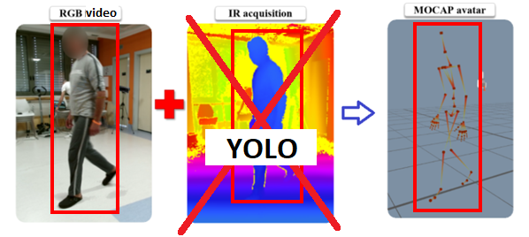
Figure 1
The gait evaluation process will be done in a bi-level procedure. First, detecting the person in hand from a video. Detecting an object which is in motion, incorporates two stages: object detection [7] and object classification [8]. Recently, deep neural networks have been demonstrated to achieve superior object detection performance compared to other approaches. Yolov4 is one of the state-of-the-art DNN-based object detection methods in terms of both speed and accuracy and for those reasons we chose to use it. YOLO object detection approach [YOLO] proposes formulating the object detection problem as a single regression problem, where bounding box coordinates and class probabilities are computed at the same time. Models based on the YOLOv4 network will be trained and tested on a suitable database. Second, after detecting the object, in our case the walking patient we need to analyze his\her gate performance. For the assessment to be accurate the skeleton figure should be extracted. The shape skeleton, or medial axis [5], is a structure based object descriptor that reveals local symmetry as well as connectivity between object parts [6]. The Skeleton model can describe motion joints precisely and does not include factors that are not relevant to the assessment. The estimation of the skeleton model will be performed using a trained Convolutional Neural Network (CNN) model.
Table 1
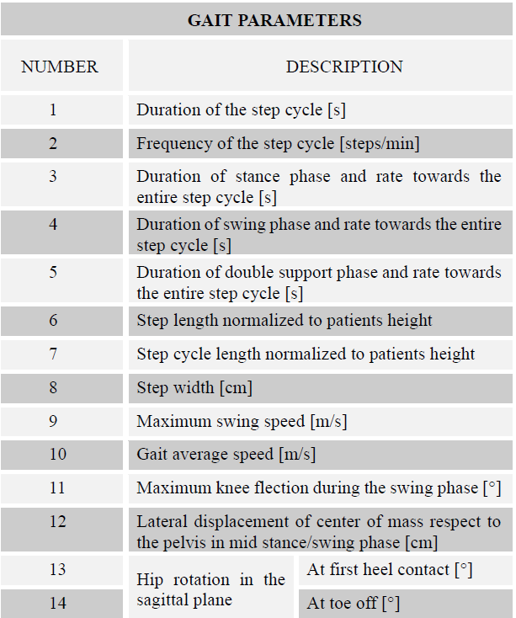
A multidisciplinary approach is needed to understand which are the right gait parameters. Table 1 describes numerous parameters that help to determine gait quality by measuring gait characteristics (e.g., step cycle, phase of a step, length of step) [3]. These parameters will be analyzed and interpreted to create results so the final users - medical personnel, can be provided exactly with the information they need.
As part of the project, we will develop an application that can take as input RGB video and automatically generate skeleton figures characterizing patients' gait performance. In this way, a complex gait evaluation is possible with a few and available means in a short time. This allows transforming the real gait of a patient after a surgical procedure or injury into a set of scores of medical relevance evaluation and significantly improve the rehabilitation process.

Background of YOLO algorithm
How amazing would it be if we could make a machine observe a situation and know exactly what objects are in it, what is the context of it and do it fast and accurately as humans do. Human observation is not just seeing the objects, when a person observes a situation, his brain is making many processes. First, the brain gets the picture from the eyes of the person, then it identifies and analyzes it, and finally, it needs to send action commands to the body. All this complex process takes just a fraction of a second.
YOLO algorithm is a milestone in the evolving field of computer vision. YOLO is a fast real-time multi-object detection algorithm, which was first outlined in this 2015 paper by Redmon et al. from the University of Washington. The idea behind the algorithm is to reframe object detection as a single regression problem, straight from image pixels to bounding box coordinates and class probabilities. YOLO composed of a single convolutional network simultaneously predicts multiple bounding boxes and class probabilities for those boxes.
In the YOLO model the image is divided into an S x S grid and for each grid cell predicts B bounding boxes, confidence for those boxes, and C class probabilities. These predictions are encoded as an S x S x (B * 5 + C) tensor.
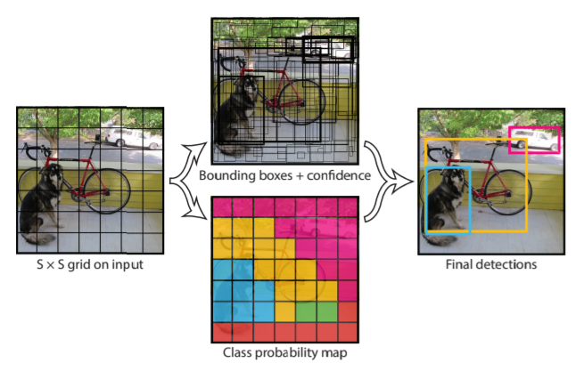
Figure 4
Our research aims to detect and record human gait in video taken in rehabilitation center using YOLO algorithm. To build the model, a database contains videos with gait classification in terms of health is needed. In addition, the model should be able to process the video sequence “online” to help the patient fix mistakes and walk correctly.
Gait detection using YOLO consist of several steps. The first step is to train the model to detect objects as humans in a single frame. Then we change the network structure to achieve multi frame information so the model would be able to track the object and detect gait action. The next step is to recognize the joints in the identified posture thus creating a skeleton figure.
The skeleton figure requires tracking to follow up the movement of the person. Our goal is to keep track of the joints and so we can achieve further analysis of a person’s gait.
A research made about terrorist and illegal migration detection in difficult weather [9] found YOLO to be significantly faster than the other detector they examined and the only detector that can process a video sequence “online”.
Since 2015 when YOLO was first introduced by Joseph Redmon et al. subsequent versions were published and, in each version, improvements have been made. We will explain every version and compare them.
YOLOv1 [10] main idea was to take an entire picture as an input of the network and directly regress the position and category of the bounding boxes in the output layer. The network design (represented in Figure 4) consists of 24 convolutional layers that act as a feature extractor. They are followed by 2 fully connected layers that responsible for the classification of objects. YOLOv1 uses 1 x 1 reduction layers followed by 3 x 3 convolutional layers.
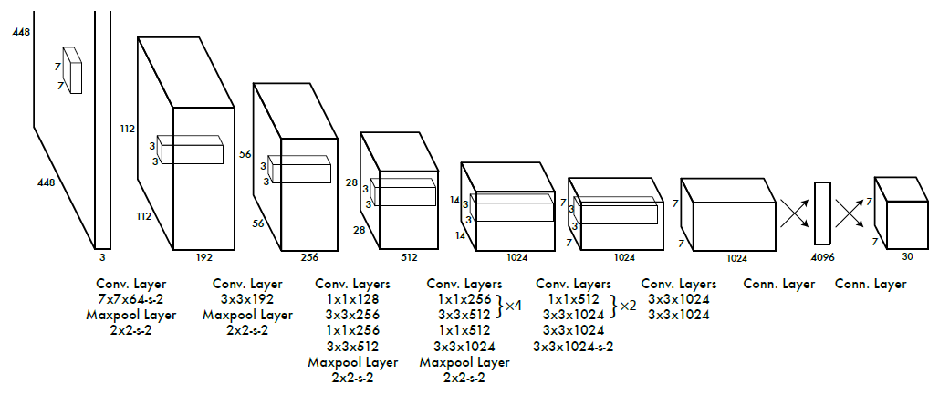
Figure 5
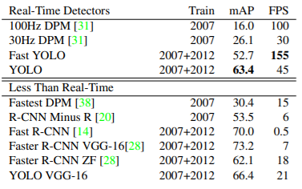
YOLOv1 results are listed in Figure 4. YOLOv1 achieves 45 FPS and 63.4% mAP which are significantly higher compared to DPM (another real-time object detector). Even though Faster R-CNN VGG-16 has higher mAP, its speed much slower than YOLO's speed.
YOLOv1 has some limitations, it has difficulties in detecting small objects that appear in groups and objects having unusual aspect ratios and it makes more localization errors compared to Fast R-CNN.
Figure 6
YOLOv2 [11] also called YOLO9000 because it can detect over 9000 object categories is more accurate and still fast. YOLOv2 include the mentioned below improvements:
Batch normalization was added to the architecture, so we can increase the convergence of the model that leads us for faster training. The mAP increased by more than 2% as compared to basic YOLO.
High resolution classifier: The YOLOv2 version trains on 448 * 448 resolution for 10 epochs on ImageNet data. This gives network time to adjust the filters for higher resolution. This increases the mAP by 4%.
Use anchor boxes for bounding boxes: YOLOv2 removes all fully connected layers and uses anchor boxes to predict bounding boxes and one pooling layer to increase the resolution of the output. The size of the input is changed to 416 x 416 so the number of locations in the feature map is odd and that way we get a single center cell. With anchor boxes, 69.2% mAP and recall of 88% are obtained. Though mAP is dropped a little, recall is increased by large margin.
Dimension Clusters: A k-means clustering is run on the training set Bounding Box to automatically find good priors.
Fine-Grained Features: YOLOv2 which generates 13 * 13 is sufficient for detecting large objects. To detect finer objects the architecture was modified such that the output of previous layer 26*26*512 to 13*13*2048 and concatenates with the original 13*13*1024 output layer making our output layer of size.
Multi-scale training: YOLO v2 has been trained on different input sizes from 320 * 320 to 608 * 608 using step of 32. This architecture randomly chooses image dimensions for every 10 batches. This makes sure that network can predict detentions at different resolutions.
Darknet-19 classification is used for feature extraction. This architecture has lower model complexity and therefor much faster detection speed.
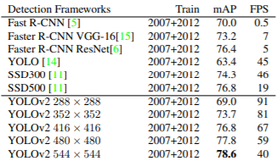
Figure 6 represents the results of YOLOv2. It is faster and more accurate than prior detection methods and it can run on different resolutions for an easy tradeoff between speed and accuracy.
Figure 7
YOLOv3 [12] refined the design by using multi-scale prediction and bounding box prediction using logistic regression. While the accuracy increased dramatically with this version, it traded off against speed which reduced from 45 to 30 frames per second.
YOLOv3 uses a variant of Darknet, a framework to train neural networks, which originally has 53 layers. For the detection task, another 53 layers are stacked onto it, accumulating to a total of a 106-layer fully convolutional architecture. This explains the reduction in speed in comparison with the second version, which only has 30 layers.
Improvements made in YOLOv3:
Bounding box prediction: YOLO_v3 predicts an objectness score for each bounding box using logistic regression. The width and height of the box are predicted as offsets from cluster centroids. We predict the center coordinates of the box relative to the location of filter application using a sigmoid function.
Class prediction: uses of Logistic function Classifier for class prediction instead of a softmax function as used in YOLO v2. This helps in multi-label classification.
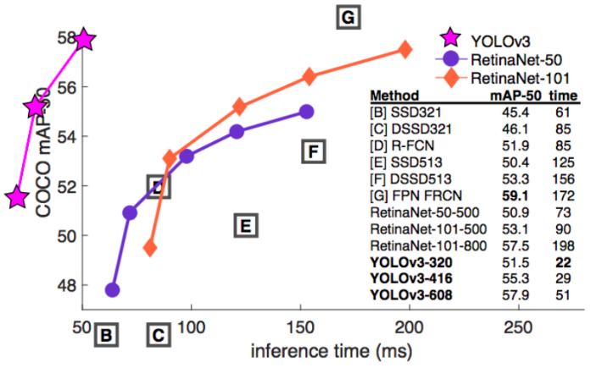
Predictions across scales: YOLOv3 uses Feature Pyramid Networks to make predictions at varied scales. The last prediction benefit from all the prior computation.
Figure 7 represent comparison between YOLOv3 and other detectors. It is relatively fast and accurate but not the most accurate.
Figure 8
YOLOv4 [13] is an efficient and powerful object detection model that enables anyone with a 1080 Ti or 2080 Ti GPU to train a super-fast and accurate object detector. It has improved in terms of accuracy and speed.
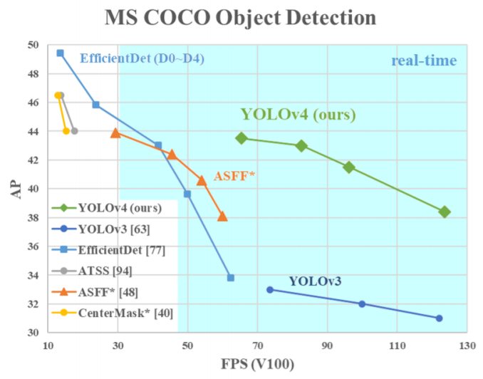
Figure 7 represent a comparison of YOLOv4 and other object detectors. YOLOv4 runs twice faster than EfficientDet with comparable performance. In addition, AP (Average Precision) and FPS (Frames Per Second) increased by 10% and 12% compared to YOLOv3.
Figure 9
YOLOv4’s architecture is composed of CSPDarknet53 as a backbone, spatial pyramid pooling additional module, PANet path-aggregation neck and YOLOv3 head.
CSPDarknet53 can enhance the learning capability of CNN. The spatial pyramid pooling block is added over CSPDarknet53 to increase the receptive field and separate out the most significant context features. Instead of Feature pyramid networks (FPN) for object detection used in YOLOv3, the PANet is used as the method for parameter aggregation for different detector levels.

Related work

Gait Analysis and Gait Disorders
Human gait depends on a complex interplay of major parts of the nervous, musculoskeletal and cardiorespiratory systems. A person’s gait pattern is strongly influenced by age, personality, and mood. Moreover, sociocultural factors play a role: for instance, persons living in large cities walk significantly faster than those living in rural areas [14]. Walking is a sensitive indicator of overall health status and the self-selected walking speed closely correlates with individual life expectancy in elderly persons [15].
The causes of gait disorders include neurological conditions (e.g., sensory or motor impairments), orthopedic problems (e.g., osteoarthritis and skeletal deformities) and medical conditions (e.g., heart failure, respiratory insufficiency, peripheral arterial occlusive disease and obesity). In older age, gait disorders typically have several causes, which may include impaired proprioceptive function in polyneuropathy, poor vision, frontal gait disorder associated with vascular encephalopathy and osteoarthritis of the hips or knees. If a gait disorder has an acute onset, cerebrovascular, spinal and neuromuscular causes should be considered, as should adversely drug effects and psychiatric disorders. Possible medical causes include cardiorespiratory or metabolic disturbances and infections [16].

Gait disorders in adults and the elderly
To analyze gate pattern in terms of normal and pathological we need a definition and parameters that describe them. An article published in 2016 by Walter Pirker and Regina Katzenschlager [17] provides an overview on the phenotypic spectrum, work-up and treatment of gait disorders. It describes the physiological basis of gate, clinical examination of gate and gate disorders classifications.
Initiating gait requires a stable upright body position, functioning postural reflexes are necessary to assume and sustain a stable body position. To start walking, one leg is raised and directed forward by flexing the hips and knee. Activation of the supporting contralateral leg and trunk muscles moves the body’s center of gravity over the weight-bearing leg and forward. The heel of the swinging leg is then placed on the ground. The body weight is gradually shifted to the sole and then onwards to the toes. During mid-stance, the opposite leg is lifted and moves forward until the heel strikes the ground. Meanwhile, the body is held upright, the shoulders and pelvis remain relatively level and each arm swings in the direction opposite to that of its ipsilateral leg.
The gait cycle (Figure 10) is divided into the stance and swing phase [18][19]. The stance phase constitutes approximately 60 % of the gait cycle and is subdivided into:
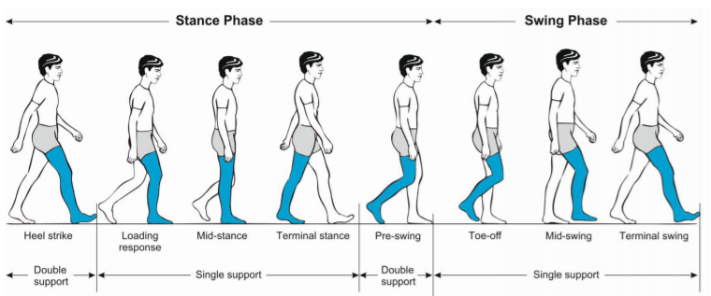
- initial contact (heel strike).
Figure 10 Phases of normal gate cycle [17]
- loading response.
- mid-stance.
- terminal stance.
- pre-swing. Both feet are on the ground at the beginning and end of the stance phase. Each of these two double support periods lasts for approximately 10–12 % of the gait cycle. The swing phase takes up about 40 % of the gait cycle and is subdivided into:

- initial swing (toe off).
- mid-swing (tibia vertical).
- terminal swing, terminated by the heel striking the ground.
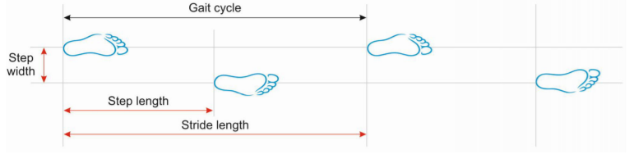
Figure 11 Basic terminology describing the gate cycle [17]
Important measures of gait (Figure 11) include:
- walking speed.
- cadence (number of steps per unit of time).
- walking base width (measured from midpoint to midpoint of both heels).
- step length (measured from the point of foot contact to the point of contralateral foot contact).
- stride length (linear distance covered by one gait cycle).
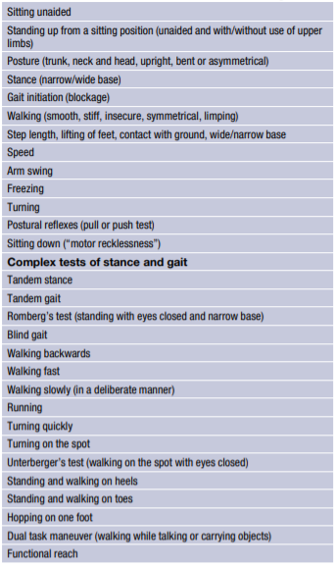
The preferred walking speed in healthy adults up to the age of 59 years is approximately 1.4 m/s [20]. Average stride lengths in healthy adults’ range between 150 and 170 cm. The average cadence in young adults was reported to range between 115 and 120 steps/min. Ageing is associated with a decline in gait speed and step length whereas cadence remains relatively stable. Elderly subjects prefer a 40 % wider step width than young persons (average step width in elderly women approximately 8 cm and in elderly men 10 cm) [21].
Table 1 Parameters for the clinical examination
of gate [17]
Clinical examination of gait provides an overview of the function of the structures involved in walking. In the examination process it is important to observe the entire patient, from the front and from all sides, while walking over a distance of at least several meters without obstacle and it is recommended that the patient wont were shoes. Table 1 summarizes the parameters that should be clinically examined, which include step length, stride length, step width, rhythm, speed, posture, swinging of arms and legs and the duration and type of contact with the floor [22].
The Bruneck study, in which a representative sample of the population of a small region in northern Italy is being followed longitudinally, has provided valuable epidemiological data on various gait disorders in 488 persons: between the ages of 60 and 97 years one third of this population had a gait disorder, with a marked increase in prevalence with age, between the ages of 60 and 69 years, the prevalence was 10 % and in those over 80 years it was >60 % [24]. In two thirds of those affected by any gait disorder, the cause was neurological and in approximately one half, the cause was nonurological, indicating that there was a considerable overlap of patients affected by neurological as well as by non-neurological gait disorders. Among the neurological causes, sensory ataxia (18 %) and parkinsonian (16 %) gait disorders were the most common, followed by frontal (8 %), cerebellar ataxic gait disorders, cautious gait and hypotonic paretic, spastic, vestibular and dyskinetic gait disorders. In approximately one third of the patients the gait disorder was due to more than one neurological cause, making a precise classification difficult [24]. It must be pointed out that these prevalence rates refer to elderly people living in the community. Substantially higher rates of gait disorders are to be expected among geriatric hospital and nursing home residents [28].
The article reviews several common gate disorders and their phenomenological classification (table 2). The gate disorders can be divided into the following categories:
- Musculoskeletal gait disorders: Osteoarthritis and skeletal deformities of the lower extremities are the most common reasons for non-neurological gait disorders in adults [11]. The resulting orthopedic gait disturbances may be characterized by a limited range of motion, avoidance of weight-bearing and asymmetry or limping.
- Neuromuscular and myelopathic gait disorders: Peripheral paresis that is severe enough to cause a gait disorder can usually be detected on standard clinical neurological examination.
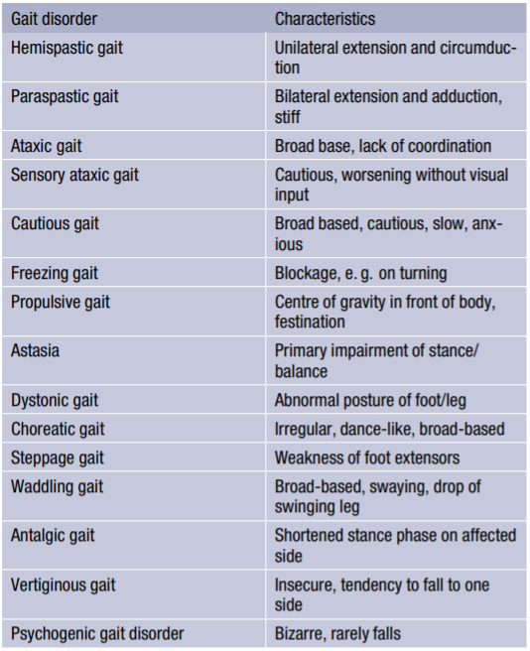
- Gait disorders associated with brain dysfunction: This category encompasses all gait disorders related to brain disease or dysfunction, i.e., the neurological gait disorders in a narrower sense. It largely overlaps with the categories of middle and higher-level gait disorders in the classification proposed by Nutt et al. [25–27]; however, some middle level gait disorders, such as spastic gait may also be caused by spinal lesions.
Table 2 Table 3 Phenomenological classification of
gait disorders (modified from Ru ˇzi ˇcka and Jankovic [23].
Any gait disorder should be thoroughly investigated to improve patient mobility and independence, to prevent falls and to detect the underlying causes as early as possible. Thorough clinical observation of gait, careful history taking focused on gait and falls, and physical, neurological and orthopedic examinations are basic steps in the categorization of gait disorders and serve as a guide for ancillary investigations and therapeutic interventions. Several gait disorders are amenable to specific treatment. Levodopa is the drug of choice for the treatment of the gait disorder of PD and in some other parkinsonian syndromes. Rare conditions, such as myoclonus and orthostatic tremor also may respond well to medication. In normal pressure hydrocephalus, cervical spondylitis myelopathy, lumbar spinal stenosis and hip or knee osteoarthritis, surgical treatment should be considered. Patients with gait disorders not amenable to specific treatment (e. g. many neuromuscular conditions, frontal gait disorders) may benefit from multimodal rehabilitation, gait training, use of assistive devices and fall prevention measures. Commonly used exercise interventions such as muscle strength, power, and resistance training as well as coordination training can improve habitual and maximum gait speed in elderly subjects [29]. These exercise programs can be individualized according to the type of gait impairment, the therapist’s experience, and patient’s preferences.

References:

[1] Roy B. Davis III, Sylvia Õunpuu, Dennis Tyburski, James R. Gage, “A gait analysis data collection and reduction technique”, Human Movement Science
Volume 10, Issue 5, October 1991, Pages 575-587.

[2] Walter Pirker, Regina Katzenschlager, “Gait disorders in adults and the elderly”, October 2016.

[3] Daniele Regazzoni, Andrea Vitali, Filippo Colombo Zefinetti, Caterina Rizzi, “Gait Analysis in the Assessment of Patients Undergoing a Total Hip Replacement”, In ASME International Mechanical Engineering Congress and Exposition (Vol. 83518, p. V014T14A003). American Society of Mechanical Engineers.‏

[4] Kwang Gi Kim, PhD, “Deep Learning”, Healthcare Informatics Research October 2016.

[5] Harry Blum, “Biological shape and visual science (part I)” Journal of Theoretical Biology Volume 38, Issue 2, February 1973, Pages 205-287.

[6] D. Marr, H. K. Nishihara, “Representation and recognition of the spatial organization of three-dimensional shapes”, February 1978.

[7] Irene Anindaputri Iswanto, Tan William Choa, Bin Li, “Object Tracking Based on Meanshift and Particle-Kalman Filter Algorithm with Multi Features”, Procedia Computer Science Volume 157, 2019, Pages 521-529.

[8] Omar Javed, Mubarak Shah, “Tracking and Object Classification for Automated Surveillance “, ECCV '02: Proceedings of the 7th European Conference on Computer Vision-Part IV, May 2002, Pages 343–357.

[9] MATE KRIŠTO, MARINA IVASIC-KOS, (Member, IEEE), AND MIRAN POBAR, “Thermal Object Detection in Difficult Weather Conditions Using YOLO”, July 2020.

[10] Joseph Redmon, Santosh Divvala, Ross Girshick, Ali Farhadi, “You Only Look Once: Unified, Real-Time Object Detection”, May 2016.

[11] Joseph Redmon, Ali Farhadi, “YOLO9000: Better, Faster, Stronger”, Dec 2016.

[12] Joseph Redmon, Ali Farhadi, “YOLOv3: An Incremental Improvement”, Apr 2018.

[13] Alexey Bochkovskiy, Chien-Yao Wang, Hong-Yuan Mark Liao, “YOLOv4: Optimal Speed and Accuracy of Object Detection”, Apr 2020.

[14] Ebersbach G, Sojer M, Muller J, Heijmenberg M, Poewe W. Sociocultural differences in gait. Mov Disord. 2000;15(6):1145–7.
[15] Studenski S, Perera S, Patel K, Rosano C, Faulkner K, Inzitari M, et al. Gait speed and survival in older adults. JAMA. 2011;305(1):50–8.
[16] Alexander NB, Goldberg A. Gait disorders: search for multiplecauses. CleveClin JMed. 2005;72(7):586.
[17] Pirker, W., Katzenschlager, R. Gait disorders in adults and the elderly. Wien Klin Wochenschr 129, 81–95 (2017). https://doi.org/10.1007/s00508-016-1096-4
[18] Ružicka E, Jankovic JJ. Disorders of gait. In: Jankovic ˇ JJ, Tolosa E, editors. Parkinson’s disease and movement disorders, 4th edn. Philadelphia: Lippincott, Williams and Wilkins; 2002. pp. 409–29.
[19] Lim MR, Huang RC, Wu A, Girardi FP, Cammisa FP Jr.. Evaluationof theelderlypatientwithanabnormalgait. JAm AcadOrthop Surg. 2007;15(2):107–17.
[20] Bohannon RW, Williams Andrews A. Normal walking speed: a descriptive meta-analysis. Physiotherapy. 2011;97(3):182–9.
[21] Aboutorabi A, ArazpourM, BahramizadehM,Hutchins SW, Fadayevatan R. The effect of aging on gait parameters in able-bodied older subjects: a literature review. Aging Clin ExpRes. 2015;doi:s40520-015-0420-6.
[22] Snijders AH, van de Warrenburg BP, Giladi N, Bloem BR. Neurological gait disorders in elderly people: clinical approach andclassification. LancetNeurol. 2007;6(1):63–74.
[23] Ružicka E, Jankovic JJ. Disorders of gait. In: Jankovic ˇ JJ, Tolosa E, editors. Parkinson’s disease and movement disorders, 4th edn. Philadelphia: Lippincott, Williams and Wilkins; 2002. pp. 409–29.
[24] Mahlknecht P, Kiechl S, Bloem BR, Willeit J, Scherfler C, Gasperi A, et al. Prevalence and burden of gait disorders in elderly men and women aged 60–97 years: a populationbasedstudy. PLOSONE. 2013;8(7):e69627.
[25] Nutt JG, Marsden CD, Thompson PD. Human walking and higher-level gait disorders, particularly in the elderly. Neurology. 1993;43(2):268–79.
[26] Nutt JG. Classification of gait and balance disorders. Adv Neurol. 2001;87:135–41.
[27] Nutt JG. Higher-level gait disorders: an open frontier. Mov Disord. 2013;28(11):1560–5.
[28] Sudarsky L. Gait disorders: prevalence, morbidity, and etiology. AdvNeurol. 2001;87:111–7.
[29] Hortobagyi T, Lesinski M, Gabler M, VanSwearingen JM, Malatesta D, Granacher U. Effects of three types of exercise interventions on healthy old adults’ gait speed: A systematic review and meta-analysis. Sports Med. 2015;45(12):1627–43.

